Assignment 1 - Requirements Specifications

Topic: Online Electronics Store (AWE Electronics - Online)

Introduction 3
Project Overview 3
Goals 3
Assumptions 3
Scope 4
Problem Domain Expansion 4
Pain Points 4
Domain Entities 4
Actors 4
Domain Model 5
Domain Vocabulary 5
Tasks 6
Functional Requirements and Task Descriptions 6
Task 1: Create a customer account 6
Task 2: Manage customer’s information 7
Task 3: Search for the desired product 8
Task 4: Select products and manage the order 9
Task 5: Process payment for the order 10
Task 6: Manage the delivery information of the order 11
Task 7: Change the displayed products 12
Task 8: Show basic statistics about the goods sold 13
Workflow 15
Task 1: Create a customer account 15
Task 2: Manage customer’s information 16
Task 3: Search for the desired product 17
Task 4: Select products and manage the order 18
Task 5: Process payment for the order 19
Task 6: Manage the delivery information of the order 20
Task 7: Change the displayed products 21
Task 8: Show basic statistics about the goods sold 22
Quality Attributes of System 23
Security 23
Performance 23
Maintainability 24
Scalability 24
Other Requirements 25
Validation of Requirements 26
CRUD Check 26
Possible Solutions 27
Web Application 27
Mobile Application 27

Introduction
This specification document is for a Online Electronics Store system that will assist AWE Electronics in expanding its operation online and tasks regarding the selling process, managerial and statistical functions.

This document serves to cover the requirements and quality attributes of the Online Electronics Store for AWE Electronics, namely through the analysed functional requirements that have been separated into user tasks, using the Tasks & Support approach.

Project Overview
The store owners of AWE Electronics have expressed an interest in expanding their operations online. Their current system is operating a local store situated at Glenferrie Road, limiting their reach to nearby suburbs encompassing the area. For this reason, the store owners of AWE Electronics have contacted Swinsoft Consulting to assess and develop the specifications required for a new Online Electronics Store system that will extend their reach to customers Australia-wide.

The document is a requirements specification for the Online Electronics Store for AWE Electronics, using the Tasks & Support approach, in order to better assess the required
development efforts (as well as associated costs).

Goals
The goal of the document is to lay out domain-level requirements (i.e. the tasks that users want/need to perform with the support of the envisaged online store). Furthermore, taking the
identified user tasks as well as the application domain into consideration, identify and
appropriately specify four quality attributes (i.e. non-functional requirements) that we
consider being particularly important for the Online Electronics Store.

Assumptions
- The delivery range of the OES (Online Electronic Store) is only within Australia.
- The OES is ready for putting in use as soon as it is completed.
- Payment made in the OES is through Australian bank cards only.
- There are only two types of accounts in the OES:
  - The owner account which is unique and set up from the beginning and the customer account which can be created and accessed whenever a customer wants to buy something.
  - Each customer account is distinguished through the phone number registered which must be an Australian number and there is no restriction over the number of customer accounts that can be made within the store.
- There is no classification over the products sold in the OES and they will all be considered electronic products in general and organized in alphabet order.

Scope
The scope of the project is to create an online platform where customers can access and make orders for the products displayed within the store and the owner can make changes to products displayed and look at statistics over the number of products sold. This means anything outside the scope such as allowing and maintaining the platform to be displayed online, managing the products stock or in this case, creating an actual payment system getting money from the customers’ bank account.

Problem Domain

Pain Points
- Prevent access to one account from multiple sources.
- Record customer’s information and orders.
- Fulfill the privileges of the owner.

Domain Entities
- Customer
- Owner
- Product
- Order
- Invoice

Actors
- Customer
- Owner

Domain Model

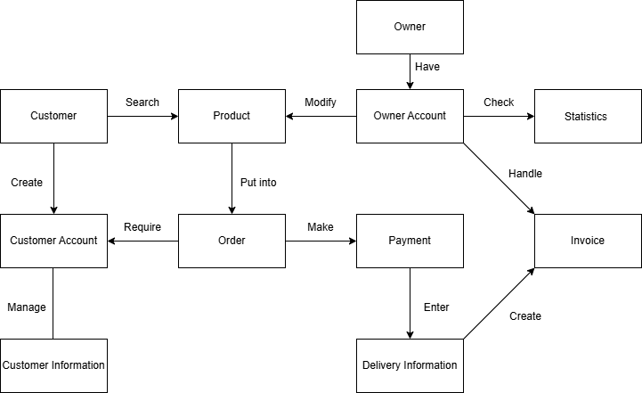

Domain Vocabulary
- Owner: The person who sells products in the store.
- Customer: Anyone who is not the owner and wants to buy the products in the store.
- Product: Anything sold in the store.
- Order: A list of products that the customers have the intention to buy and is changeable until the customers decide to place the order.
- Account: An arrangement with the store that allows the user to do a range of functions equipped for them.
- Customer Information: Details about the customer including their name, gender, age and so on
- Delivery Information: Details about the destination to deliver the paid products of the order.
- Invoice: A list of products that have been paid, work that has been done, etc., showing what customers have done to place the order.
- Statistics: Numbers about products sold over different periods of time.

Tasks
- Create a customer account
- Manage customer’s information
- Search the desired product
- Select products and manage the order
- Process payment for the order
- Manage the delivery information of the order
- Change the displayed products
- Show basic statistics about the goods sold

Functional Requirements and Task Descriptions

Task 1: Create a customer account

Task: Create a customer account
Purpose: | Allows the customer to proceed with the purchasing process.
Trigger/Precondition: | The customer has expressed interest in a product and wishes to purchase it.
Frequency: | Average of 3 sign-ups per day.
Critical: | A sudden influx of sign-ups (15+).
Work Area: | Sign-up Page.
Subtasks: | Example Solution:
1. Customer navigates to the Sign-Up page. | System redirects the customer to the Sign-Up page.
2. Customer enters account creation details.  Problem: Details entered (email or phone number) is invalid. | System verifies the email and phone number. System will also check that the password is secure.
3. Submit account creation information. | System writes the new account details into the database.
4. Customer logs into the new account. | System activates the newly created account.
Variants:
2a. An account already exists under the entered email address. | System will notify the customer that an account already exists under that email address.
2b. Registration details are invalid. | System will notify the customer of the specific part wrong.

Task 2: Manage customer’s information

Task: Managing customer’s information
Purpose: | Customer ensures that their account details and shipping address are correct.
Trigger/Precondition: | The customer wishes to update/change their account details.
Frequency: | Average of 2 updates per day.
Critical: | A sudden influx of account updates at once (15+).
Work Area: | Customer Profile.
Subtasks: | Example Solution:
1. Customer navigates to their Account Details page.  Problem: Customer is not yet logged in. | System redirects the customer to their Account Details page.  System will omit additional options to be selected prior to being logged in.
2. Customers select and update their details.  Problem: New email, shipping address or phone number is invalid. | System verifies the new changes before allowing them to be saved.
3. Save changes. | System updates the database with the changes made.
Variants:
Invalid info has provided | System highlights errors and prevents saving until resolved
Haven’t logged in | System prompts login before showing account details

Task 3: Search for the desired product

Task | Details
Purpose: | To provide customers with a seamless and intuitive search experience, allowing them to find products quickly and accurately, thereby enhancing user satisfaction and engagement.
Trigger/Precondition: | Initiated when a customer wishes to locate a specific product or category within the online store. Requires an active internet connection and access to the store's website or application.
Frequency: | This function is expected to be used frequently, with an average of 20 search operations per day.
Critical: | An unusually high number of simultaneous search queries (e.g., 50+ at once) may impact system performance, leading to slower response times. Implementing performance optimization and load management strategies is essential to mitigate this risk.
Work Area: | Search bar
Subtasks | Example Solution
1. Enter product keyword in search bar | System displays suggestions in dropdown (auto-complete or popular terms)
2. Apply optional filters | System shows options to filter by brand, price,etc.
3. Submit search | System queries the database and shows matching results
4. Browse search results | System paginates results and shows product info (name, image, price)
Variant | Solution
None

Task 4: Select products and manage the order

Task | Details
Purpose | To provide customers with a flexible and user-friendly interface for adding products to their shopping cart, managing item quantities, and ensuring order accuracy, thereby enhancing the overall shopping experience.​
Trigger/Precondition | Triggered when a customer decides to purchase one or more products after searching or browsing the online store. Requires the customer to be logged into their account.​
Frequency | Occurs with each customer purchase, averaging around 15 product selections per day.​
Critical | A sudden influx of concurrent item selections or order updates (e.g., 30+ customers adding products simultaneously) may cause inventory update delays or system strain. Implementing efficient inventory and order management mechanisms is crucial to handle such peaks.​
Work area | Shopping cart
Subtasks | Example Solution
1. Add a product to the order | Adding a product to the cart and updates the counts
2. Open the order | Displaying the current order with items, prices and total amount
3. Change the quantity of a product | System recalculates totals and verifies stock availability
4. Remove a product in the order | System removed the product from cart and update the total
5. Save the order | System maintains cart across sessions (e.g., via cookies or user session)
Variant | Solution
None

Task 5: Process payment for the order
Task | Details
Purpose | Allow the customers to start the process of placing the order in the store.
Trigger/Precondition | 1. After the customers have decided everything they want to buy and are ready to place the order.  2. There must be at least one product in their orders.
Frequency | Occurs every time a customer is ready to place an order
Critical | 30 orders are placed at a similar time which may result in delays
Work Area | Customer Order
Subtasks | Example Solution
1. Customers decide to place the order | The system gives customers the option to place the order
2. Customers check the order for one last time | The system shows the unchangeable order before giving the customers the option to go back or continue
3. Customers enter the customer information | The system gives customers the option to either use their existing customer information or enter a new one
4. Customers enter the bank card information for payment | The system requires the customer to enter every required bank card information to complete the payment
Variants:
For Subtask 1 : If it is unavailable to place the order in the store | The customers can place the order through other means such as calling or going to the shop directly which is outside the scope of this project.

Task 6: Manage the delivery information of the order

Task | Details
Purpose | Verify the precision of delivery information to effectively fulfill customer orders.
Trigger/Precondition | A customer places an order and enters delivery details.
Frequency | Occurs every time an order is placed (approx. 100 times daily).
Critical | Failure to promptly update delivery information could lead to complications in the shipping process.
Work Area | Admin Dashboard & Customer Profile.
Subtasks | Example Solution
1. Customer enters shipping details. | The system checks the accuracy of the address, and the customer provides confirmation.
2. Confirm delivery details. | Customer reviews and finalize the delivery details.
3. Track order status. | System updates delivery status as the order progresses, sending notifications.
4. Modify delivery details (if required). | Customers can update address within a 2-hour window after placing the order.
5. Confirm order delivery. | The system logs successful deliveries and enables customers to provide feedback.
Variants:
If the address is incomplete or postcode isn’t 4 digits | The system prompts re-entry before finalizing the order.
If confirmation data is invalid (e.g., phone <10 digits) | The system blocks the submission and indicates the error.
If tracking data is delayed by more than 30 minutes | The order is designated as "Delayed" by the system.
If modification is attempted after 2 hours | The system restricts editing capabilities and recommends reaching out to support for assistance.
If delivery is unconfirmed after 24 hours | The system alerts the admin for manual confirmation.
If delivery fails repeatedly | The issue is escalated to admin for manual intervention.

Task 7: Change the displayed products
Task | Details
Purpose | Allow the owner to remove, add and modify products displayed in the store.
Trigger/Precondition | When the owner wants to make changes to the list of displayed products.
Frequency | Anytime the owner wants to make changes to the list of displayed products.
Critical | The owner makes changes while customers are making orders which may cause a problem.
Work Area | Owner Account
Subtasks | Example Solution
1. Remove the displayed products | The system gives the owner the option to remove a product which is being displayed in the store.
2. Modify the displayed products | The system gives the owner the option to modify any existing information of a product which is being displayed in the store.
3. Add new products for displayed | The system gives the owner the option to add a new product to be displayed in the store. The system will require the owner to enter the new product information.
Variants:
None

Task 8: Show basic statistics about the goods sold
Task | Details
Purpose | Provide real-time analytics on product sales.
Trigger/Precondition | Admin requests a sales report.
Frequency | Daily, weekly, or on demand (approx. 1–2 times per day).
Critical | Data must be accurate for business decision-making.
Work Area | Admin Dashboard - Reports Section.
Subtasks | Example Solution
1. Select time period. | Admin chooses range (e.g., “Last 7 days”).
2. Generate analytics reports. | Displays visual insights (charts, graphs) on sales trends(e.g., 150 products sold).
3. Export and share reports. | Admin downloads reports in PDF/CSV and shares via email or dashboard.
4. Apply filters (optional). | The administrator applies filters based on category, region, or type of product.
Variants:
If time range is invalid, | The system shows an error message and prompts the user to input valid dates again.
If fewer than 5 sales are found | The system shows "No Sales Data Available" in place of empty charts.
If export fails | The system clears the filters and displays the message: “No matching records found.”.
If filtered data returns <10 results | The system clears the filters and displays the message: “No matching records found.”

Workflow

Task 1: Create a customer account
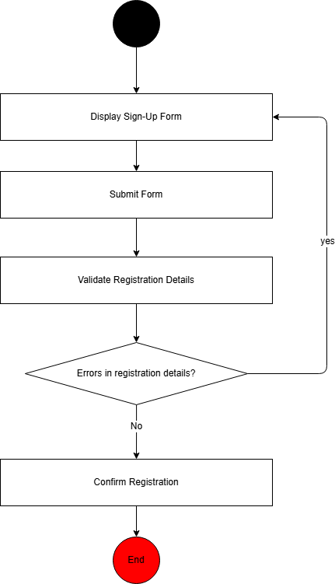

Task 2: Manage customer’s information
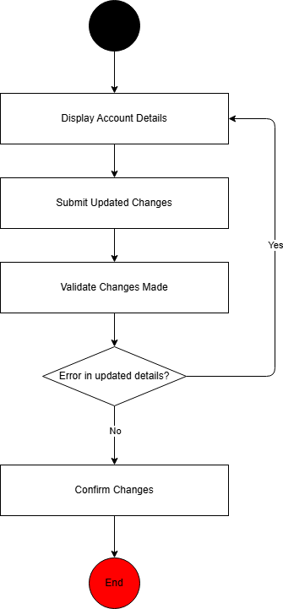

Task 3: Search for the desired product
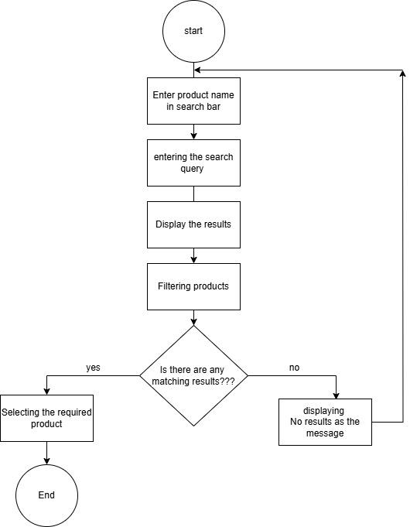

Task 4: Select products and manage the order
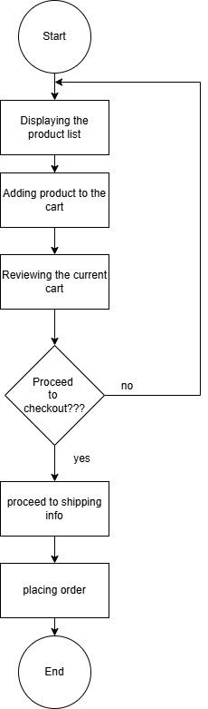

Task 5: Process payment for the order
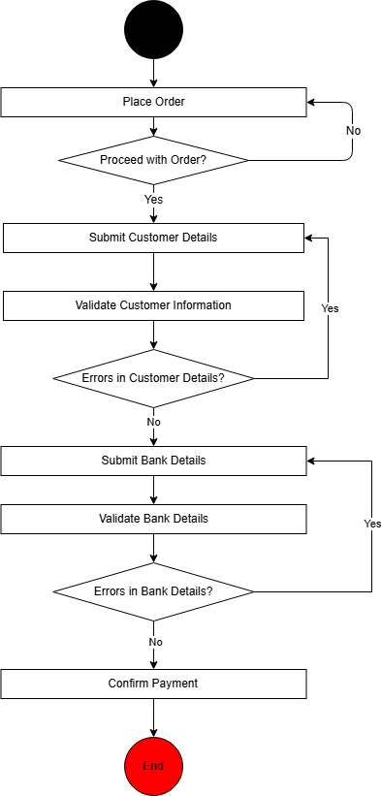

Task 6: Manage the delivery information of the order
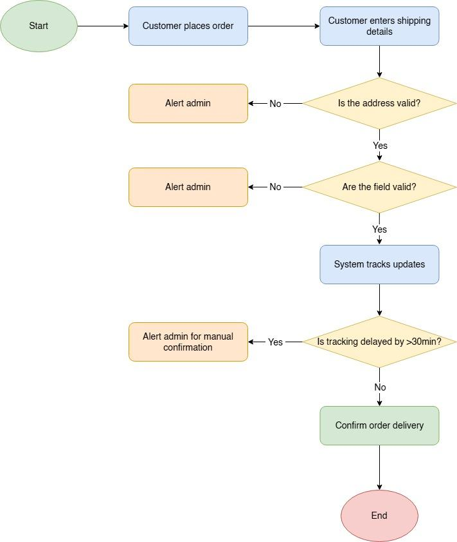

Task 7: Change the displayed products
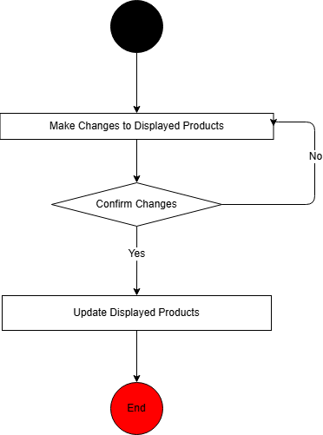

Task 8: Show basic statistics about the goods sold
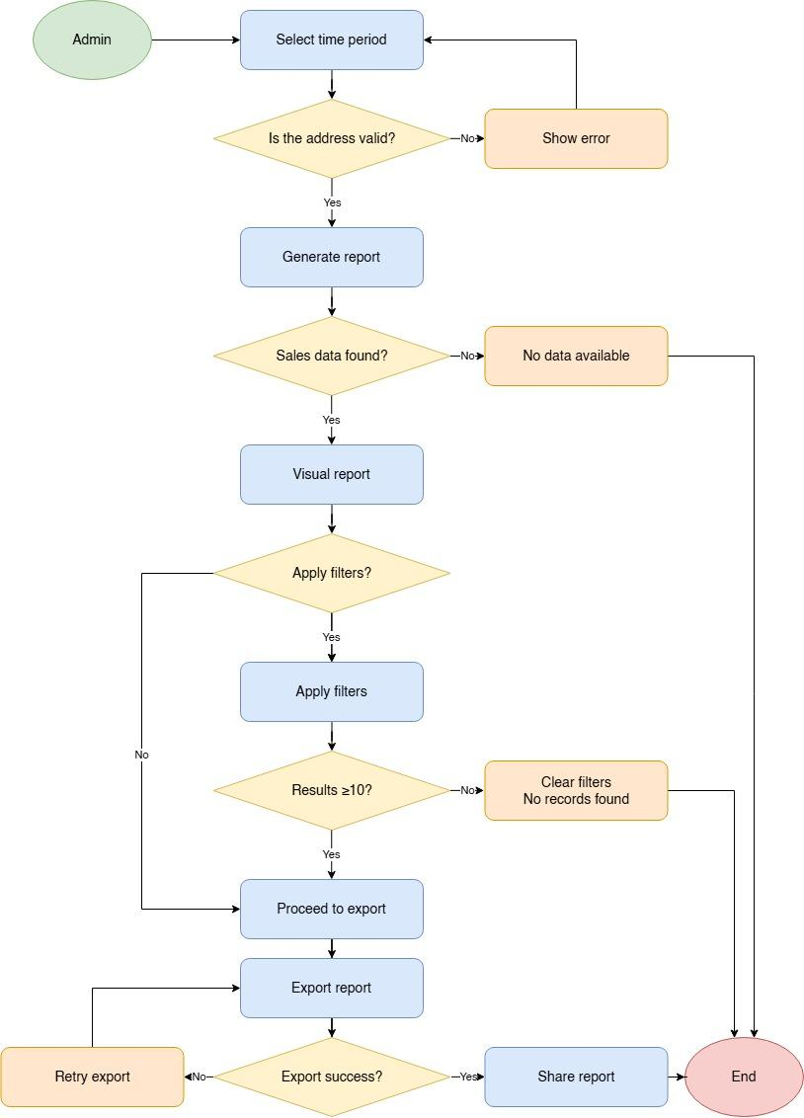

Quality Attributes of System

Security
Online shopping will inevitably lead to dealing with the customer’s personal and financial information, making security imperative as a quality attribute needed to be met by the system. The predicted online shopping scheme will revolve around customers making accounts and purchasing things. In addition to this, the owner’s account will also have elevated privileges, effectively meaning that the software must be designed and developed to prevent unauthorized access.

To meet this quality attribute the system must:
- Authorise access to the account when the correct credentials are entered.
- The storing of customer information, transactions, invoices etc, must be encrypted.
- Limit account privileges of the system based on the kind of account that exists.
  - Customer accounts will only be able to view their personal information, transactions, order history etc.
  - Owner account will be able to see a statistical view on the number of goods sold and manage what goods are to be displayed and made available on the online store.

Performance
The efficiency of the Online Electronics Store is a crucial quality attribute, ensuring that customers can browse, search, and place orders without unnecessary delays. Since the platform is expected to handle multiple concurrent users, including browsing customers and an active owner managing products, the system must be designed to maintain fast response times and smooth interactions. A slow or unresponsive platform can lead to customer frustration and potential loss of sales, making performance optimization a priority in the development process.

To meet this quality attribute, the system must:
- Ensure that search and browsing functionalities return results within an acceptable response time.
- Optimize database queries and caching strategies to handle a high volume of customer interactions efficiently.
- Implement load balancing and scalability measures to prevent slowdowns as user traffic increases.
- Ensure that order processing, including payment and invoice generation, completes within a reasonable time frame.

Maintainability
Maintainability is a crucial quality attribute that guarantees the Online Electronics Store system can adapt over time with minimal effort and risk. Given that the system must accommodate features such as product display management, delivery notifications, and analytics reporting, maintainability allows developers to implement modifications efficiently while preserving existing functionalities.

Importance:
In the highly competitive landscape of online retail, regular updates to product details, system logic, or user-facing features are vital. A maintainable system minimizes the costs, time, and errors associated with these updates, thereby promoting business agility and ensuring long-term viability.

To achieve Maintainability, the system should:

- Use a Modular Architecture
Separate concerns such as product management, order processing, delivery handling, and reporting into distinct modules. This allows developers to work on individual parts of the system without affecting others.
- Enforce Clear Coding and Documentation Standards
Consistent naming conventions, inline comments, and comprehensive documentation make it easier for current and future developers to understand, modify, and extend the codebase.
- Support Automated Testing and Continuous Integration (CI)
Implement automated unit, integration, and regression tests across core functionalities to detect issues early. CI pipelines ensure that all updates are verified before being deployed.
- Utilize Version Control with Branching Strategies
Maintain a clean Git-based workflow that enables developers to make, test, and review changes in isolation before merging into the main branch, reducing the likelihood of bugs in production.
- Enable UI-Based Configuration for Business Users
Allow the owner to manage product listings, delivery rules, and generate reports through the admin interface without requiring backend changes. This reduces the dependency on developers for routine updates.

Scalability
Scalability is a critical quality attribute for the Online Electronics Store, ensuring the platform can accommodate increasing numbers of users, products, and transactions without compromising performance or user experience. As the business grows, the system must efficiently handle heightened demands, including spikes in traffic during peak shopping periods, expansion of product catalogs, and increased concurrent user interactions. A scalable system supports business growth by maintaining responsiveness and reliability, thereby enhancing customer satisfaction and retention.​
To achieve scalability, the system should:
- Implement Load Balancing: Distribute incoming network traffic across multiple servers to prevent any single server from becoming a bottleneck, thus enhancing system responsiveness and reliability.
- Adopt a Microservices Architecture: Decompose the application into smaller, independent services that can be developed, deployed, and scaled individually, facilitating efficient resource utilization and system maintenance.​
- Utilize Database Sharding: Partition the database into smaller, more manageable pieces (shards) to improve query performance and allow for horizontal scaling as data volume grows.​
- Employ Content Delivery Networks (CDNs): Use CDNs to cache and deliver content closer to users, reducing latency and improving load times, especially during high traffic periods.​
- Optimize Code and Database Queries: Regularly review and refine code and database queries to ensure they are efficient and capable of handling increased loads without degradation in performance.​
By integrating these strategies, the Online Electronics Store can ensure its infrastructure scales effectively to meet growing business demands while maintaining a high-quality user experience.

Other Requirements
The system needs to establish a rigorous framework to ensure that every specification is fully validated before development begins. Every requirement is scrutinized for completeness, consistency, and verifiability, ensuring that it is accurately aligned with stakeholder needs. A comprehensive CRUD check is performed across all domain entities—such as customer accounts, products, orders, payments, delivery details, invoices, and administrative controls—to guarantee that each entity supports the essential Create, Read, Update, and Delete operations. This systematic mapping not only prevents potential redundancies and conflicts in data manipulation but also minimizes the need for costly rework later in the project lifecycle.
In addition to functional validations, the system must achieve stringent quality attributes that underpin superior performance and operational resilience. Robust security measures are integrated, including encryption and strict role-based access controls, to protect sensitive information during transactions and user management. Performance and scalability are ensured through efficient resource management and cloud-based load balancing, allowing the system to dynamically adjust to fluctuating user demands. Furthermore, the architecture is designed with modularity and maintainability in mind, enabling cost-effective future updates and integrations. Together, these requirements provide a solid foundation that promotes a seamless, secure, and adaptable online retail experience for both customers and administrators.

Validation of Requirements

CRUD Check

Task / Entity | Customer  Account | Product | Order | Payment | Delivery  Information | Invoice | Owner  Account | Statistics
Create a customer account | C
Manage customer’s information | R, U, D
Search the desired product |  | R
Select products and manage the order |  | R | C, R, U, D
Process payment for the order |  |  |  | C, R, U, D |  | C, R
Manage the delivery information for the order |  |  |  |  | C, R, U, D | C, R
Change the displayed products |  |  |  |  |  |  | C, R, U, D
Show the basic statistics of the goods sold |  |  |  |  |  |  | R | C, U

Possible Solutions

Web Application
This is a traditional approach to an Online Electronics Store System, which will utilise a cloud service called AWS Web services. With performance and scalability being quality attributes that need to be met, AWS Web services provide the means to scale the system effortlessly through the use of load balancing, which would regulate the responsiveness, availability and reliability of the system. AWS cloud services also offers a cost-effective way of supplying the required computing power for the system and only charges the amount used. This cuts heavily into the initial cost, as there is no need to go the traditional route of buying servers to implement this solution.
Customers who visit the AWE Electronics website will be greeted with a homepage that will feature recommended products, along with basic features such as the search bar, browse catalogue, account creation and logging in. The customer will not be requested to make an account until they decide to check-out with their selected product of choice, in which case will prompt them to create an account or login to an existing account to complete the process. Customer account management will also only become available after the customer successfully logs into their account.
The owner of AWE Electronics will have access to administrator privileges which include managing what goods will be displayed and made available on the store catalogue, and also be able to generate a statistical report on the number of goods sold over various time periods (day, week, month, year or date to date) etc. While these reports are relatively basic and without much analytics included when generated, it will provide a general understanding of which products sell well and provide valuable information for business decisions.

Mobile Application
In addition to a web application being a possible solution, it is usually accompanied by a mobile application. Many retailers that have expanded their operations online have a dedicated mobile application to serve as their shopping platform. The concept behind this approach is that by providing the customers with a streamlined purchasing process and a more catered user-friendly experience with browsing the store catalogue.
Customers who choose to use the mobile application instead of the website will be able to browse the store catalogue, search for specific products, and make a purchase once they have decided on their product of choice. All of these will be done through a user-friendly user interface with preference choices catered towards that specific customer, and the purchasing process will be less complicated than to the web application version. For these reasons, many customers might find this approach more preferable over the web application, as it is ultimately simpler and faster due to being a mobile application.
The benefit to an approach like this is dependent on the business decisions the owner wishes to make after the web application solution. The idea behind this is essentially promoting the business further onto the market, potential methods of retaining customers, and the collection of data related to customer buying tendencies. All of which translates to a potential increase in revenue, by making purchases more appealing for the customers.
The main drawback to this solution is the additional cost of developing and maintaining such application. The application has implicit requirements that make performance and usability important attributes, as customers typically choose to use the mobile application version of a store due to its responsiveness and ease of use compared to its counterpart.

